Name:S.Venikalaxmi
Reg NO:24MIS0117
project 1

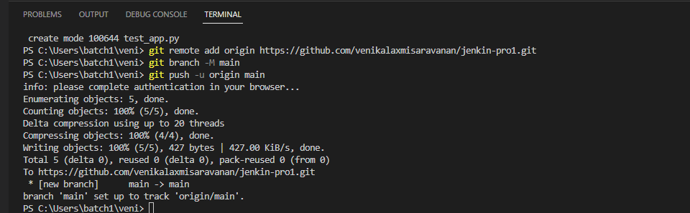

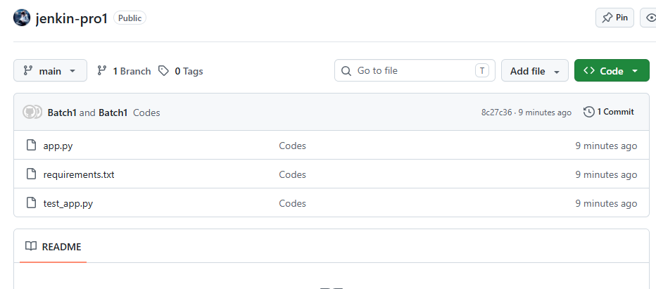
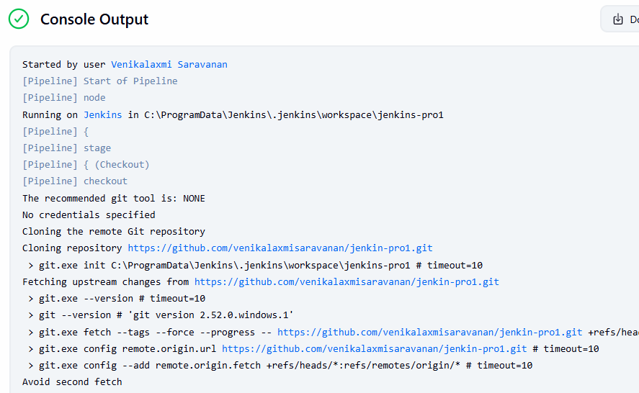

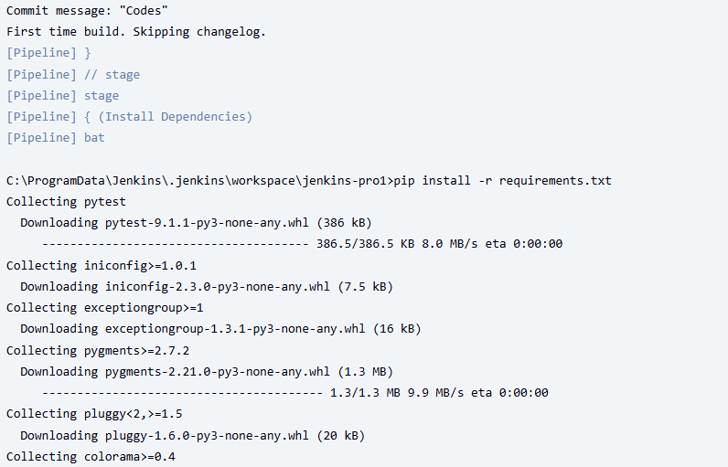

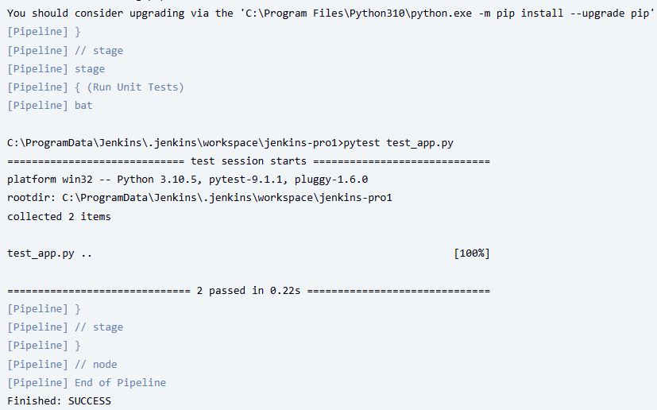

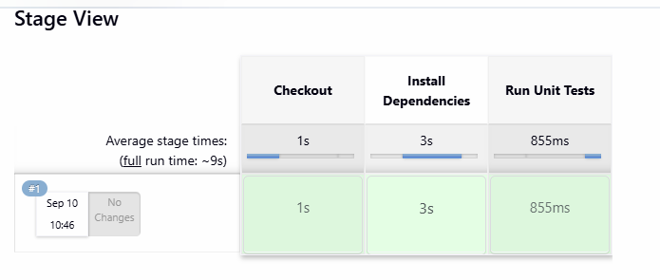
pipeline{
agent any
stages{
stage('Checkout'){
steps{
checkout scmGit(branches: [[name: '**']], extensions: [], userRemoteConfigs: [[url: 'https://github.com/venikalaxmisaravanan/jenkin-pro1.git']])
}
}
stage('Install Dependencies'){
steps{
bat 'pip install -r requirements.txt'
}
}
stage('Run Unit Tests'){
steps{
bat 'pytest test_app.py'
}
}
}
}

project 2:
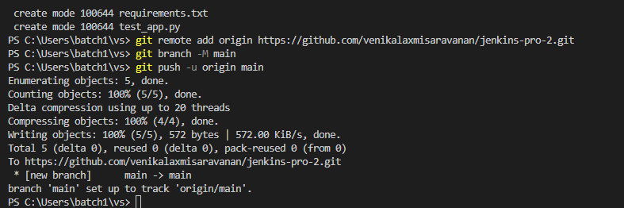
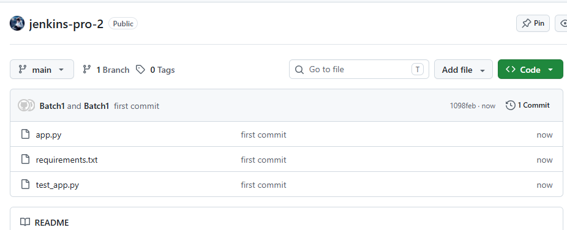

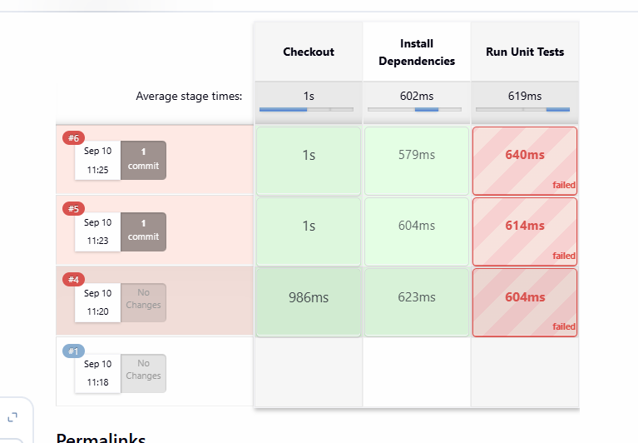

pipeline{
agent any
stages{
stage('Checkout'){
steps{
checkout scmGit(branches: [[name: '**']], extensions: [], userRemoteConfigs: [[url: 'https://github.com/venikalaxmisaravanan/jenkins-pro-2.git']])
}
}
stage('Install Dependencies'){
steps{
bat 'pip install -r requirements.txt'
}
}
stage('Run Unit Tests'){
steps{
bat 'pytest test_app.py -v'
}
}
}
}

